www.asoplc.com
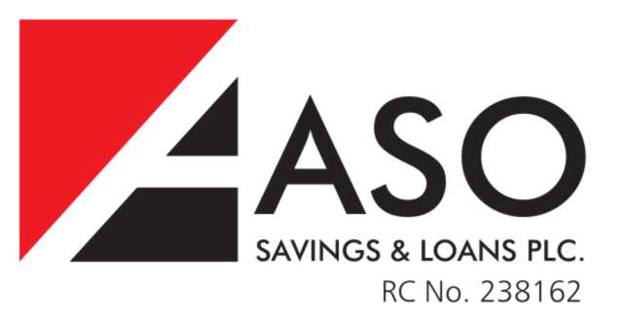
ASO INTERNET BANKING
ASO INTERNET BANKING DECLARATION
This declaration is binding on me/us, my/our successors and assigns and confirms the details of my/our application for ASO Internet Banking services and binds me/us, my/our successors and assigns to the terms and conditions thereof. I/We authorize ASO Savings & Loans Plc to charge my/our account with the cost of the Internet Banking Token (token) which I/We acknowledge is subject to change without notice to me/us. I/We understand that this token will be used by me/us at every interface with the ASO Internet Banking application to authenticate my/our password, gain access to the site, and authorize charges on my/our account for any and all transactions, transfers or recurring payments made using this medium. I/we agree that sufficient funds must be available in my/our account at any time I/we attempt make or schedule transactions, transfers or recurring payments via the ASO Internet Banking application.
I/we acknowledge that I/we have been informed that the use of the ASO Internet Banking service requires the use of both a username (emailed to the address I/we provide to ASO Customer Service Officer on my/our application for this service) and a onetime only password (provided by the token) – without which I/we cannot access my/our account information.
I/we understand that:
- I/we may access my/our accounts by computer (secure internet facility) using the provided username and one time password generated from my/our token.
- I/we may carry out transfer of funds from accounts within ASO Savings & Loans Plc.
- I/we may access information about my/our account balances, deposit and withdrawal status and view my/our last statement cycle.
- I/we understand that there will be no limit for same account transfers (ie transfers from my/our current to my savings account and vice versa); but there exists a daily limit of N250,000:00 irrespective of numbers of transfers.
- I/We have been informed that although I/we will receive monthly postal and email statements (where requested) of accounts on my/our accounts unless there are no transactions on the account in that month; I/we can access/view my/our statement of account using this internet banking service.
- Should I/we give my/our token to a 3rd party, I/we are tacitly authorizing them to act on my/our behalf, access my/our account/data; and as such agree to accept any liability arising from my/our action.
- ASO Savings & Loans Plc will not be held liable for any losses arising from unauthorized access to, or use of my/our account arising from my/our negligence/failure to safeguard and protect my/our user log in details, personal customer information, token or other functionality provided by the bank to facilitate confidentiality, integrity and accuracy of my/our data and online transactions.
- I/We agree that in event that there is a suspected unauthorized use of my/our token, I/We will immediately formally notify ASO Savings & Loans and there after co-operate fully with ASO Savings & Loans Plc and the appropriate law enforcement agency in identifying and prosecuting the perpetrator(s); and I/We will provide reasonable assistance requested by the bank in recovering any unauthorized funds transfers..
- Should I/we lose/misplace my/our token, I/we must immediately contact ASO Savings & Loans during business hours Mondays –Fridays between 8:00am and 5:00pm at any ASO Savings & Loans branch, or call 09-4611587. ASO Saving & Loans Plc will not accept notification of lost or stolen token or unauthorized transfers or transactions via email.
- ASO Savings & Loans Plc records will be final and conclusive as to all questions concerning whether or not my/our token was used in connection with a transaction. The bank shall not be held liable for any/all actions, cost and proceedings in relation to this agreement.
- ASO Savings & Loans Plc do not assume any other liability or otherwise guarantee the security of information in transit to or from our facilities. The bank reserves the right to
  - Monitor and or record all communications and activity related to the internet banking service offered to customers
  - Require verification of all requested transfers in the manner we deem appropriate before making such a transfer (which may include written or phone verification by you).
- Access to the service may be suspended at anytime without notice to maintain the integrity of the service or in instances of system failure, upgrade or maintenance or for any reasons beyond the control of ASO Savings & Loans Plc.

In consideration of being granted access by request to the ASO Internet Banking service, I/We agree to indemnify and hold ASO Savings & Loans Plc harmless for any losses or damages resulting from the use of the internet banking service, to the extent allowed by applicable law. I/We agree that ASO Savings & Loans Plc will not be held liable to me/us or any third party for the exercise of these rights here stated.
I/we acknowledge that I/we have read and understand fully the terms and conditions of this declaration and agree to be bound by them.
Dated this ___________________ day of ___________________ year________________

Please sign here

Name: _________________________________________
Designation: ____________________________________

Please sign here

Name: _________________________________________
Designation: ____________________________________

